GeoMx DSP: Host and Tumour Profiling unit, Institute of Genetics & Cancer.

If you are considering using the service:

- Reagents are ordered directly from Bruker and can be shipped directly to the facility for storage prior to the study being run. For reagents quotations, please contact Angela Lee Angela.Lee@Bruker.com

- Up to 4 morphology markers can be used to allow visualisation of the tissue and to aid segmentation strategies. Staining should be optimised prior to submission to HTPU. For protein workflows all antibodies should be conjugated. For RNA workflows antibodies can be conjugated, non-conjugated or a mixture of both, however for non-conjugated the species must not be the same.
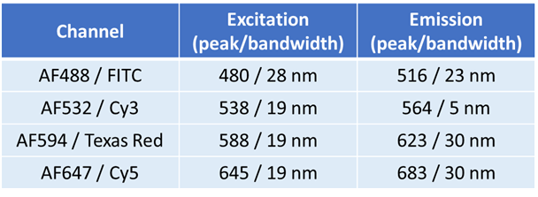

- Nuclear stains can be provided by the facility: SYTO 13 (AF488) or SYTO 83 (AF532)

- For further technical information, pricing and scheduling of studies contact the Host and Tumour Profiling Unit: nanostring@igc.ed.ac.uk

Running GeoMx DSP at HTPU, IGC:

- Once you have decided to proceed with a study, contact HTPU for pricing and scheduling of your study. For clients located outwith The University of Edinburgh a Supply of Services Agreement must be signed by both parties.

- You will be provided with a login to the GeoMx DSP which can then be accessed using a Chrome browser at https://geomx.igc.ed.ac.uk/login. If logging in from outside of the university network, VPN access will be required. We encourage users to become familiar with the software by doing the online training ahead of your study (https://university.nanostring.com/).

- Study scheduling will be discussed to ensure the timing is convenient for both the user and the facility. Typically, GeoMx slide processing is conducted on Monday and Tuesday, with slide scanning, ROI marking, and sample collection on Wednesday and Thursday. As the collection can take some time, we ask that users do ROI marking in the morning to allow collection to complete at a reasonable time.

- Sections should be cut fresh onto standard IHC slides such as SuperFrost Plus or BOND Plus at a thickness of 5 µM (FFPE) or 10 µM (Fresh/Fixed Frozen). Tissue must be placed within the scan area as shown below in green, avoiding the tip calibration area shown in red. Where possible, multiple tissue sections per slide are advised to increase cost efficiency.
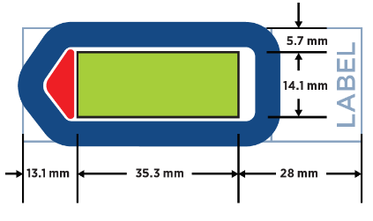

- On completion of your collection, we will finalise your samples ready for further processing via nCounter (within HTPU) or Sequencing (Genetics Core, Edinburgh Clinical Research Facility).
  - nCounter: Samples will be processed further, and data will be imported into the instrument ready for analysis by the user.
  - Sequencing: Required read depths will be discussed on completion of the collection. Facility staff will arrange the transfer of the samples to ECRF, run the NGS pipeline to convert the FASTQ files, and import the data into the instrument ready for analysis by the user.

