IGC Mass Spectrometry Facility
FFPE Tissue Sectioning, Deparaffinisation
and H&E Staining Protocol
University of Edinburgh | Institute of Genetics and Cancer | April 2026

This protocol describes how to prepare FFPE tissue sections on PEN membrane slides, perform H&E staining, image by whole-slide scanner, and store sections for subsequent laser microdissection (LMD) and Deep Visual Proteomics (DVP) analysis.

NOTE
Preferred slide format: PPS metal-frame slides (e.g., Leica PPS). Metal-frame slides are significantly more robust during staining. Glass-backed PEN slides are prone to failure during liquid steps because aqueous solutions can wick between the glass backing and the membrane, causing the membrane to lift and the tissue section to detach.
PPS metal-frame slides may be used directly without UV treatment. If using glass-backed PEN slides, treat with UV light for 1 hour before use, or coat with poly-L-lysine the day before to improve tissue adhesion.

1. Tissue Sectioning — Preparation
Equipment & Reagents
Reagent / Item | Detail
PPS metal-frame PEN slides | Preferred format (for IF) — coat with poly-L-Lysine
PEN glass slides (alternative) | UV-treat for 1 h before use—coat if needed
Microtome + fresh blade | Clean blade; always use knife guard
Water bath | Demineralised / distilled / ultrapure water, set to 45°C
Oven or slide warmer | Set to 37°C for drying
Ice | For chilling tissue blocks

Steps
- Remove FFPE tissue block from room-temperature storage. Place on ice or at -20°C for approximately 1 hour to cool and harden the paraffin — this is essential for obtaining clean, unwrinkled sections.
- Prepare slides: PPS metal-frame slides may be used directly. If using glass-backed PEN slides, treat with UV light for 1 hour, or coat with poly-L-lysine the night before.
- Fill the water bath with demineralised or ultrapure water and equilibrate to 45°C. Pure water prevents mineral deposits on the water bath surface. Warm water is critical to allow the tissue ribbon to relax and flatten before mounting.
- Set the oven or slide warmer to 37°C for overnight drying after mounting.

2. Tissue Sectioning
- Label all slides clearly with sample name, block ID, date, and your name before cutting. Labels applied after sectioning risk being placed on the wrong slide.
- Attach a clean microtome blade. Always place the knife guard over the blade when not actively cutting.
- Set the section thickness to 5–10 μm. For most DVP applications, 10 μm sections give better peptide yield; 5 μm sections give finer morphological resolution.
- Mount the tissue block in the microtome holder securely.
- Cut sections and allow the ribbon to form. Discard the first few sections until the block face is even.
- Float each section on the 45°C water bath to allow it to fully flatten. Do not leave sections in the water bath for longer than necessary.
- Mount sections by slowly raising the membrane side of the slide from beneath the floating tissue section. The tissue should adhere to the membrane surface, not the frame or label end.

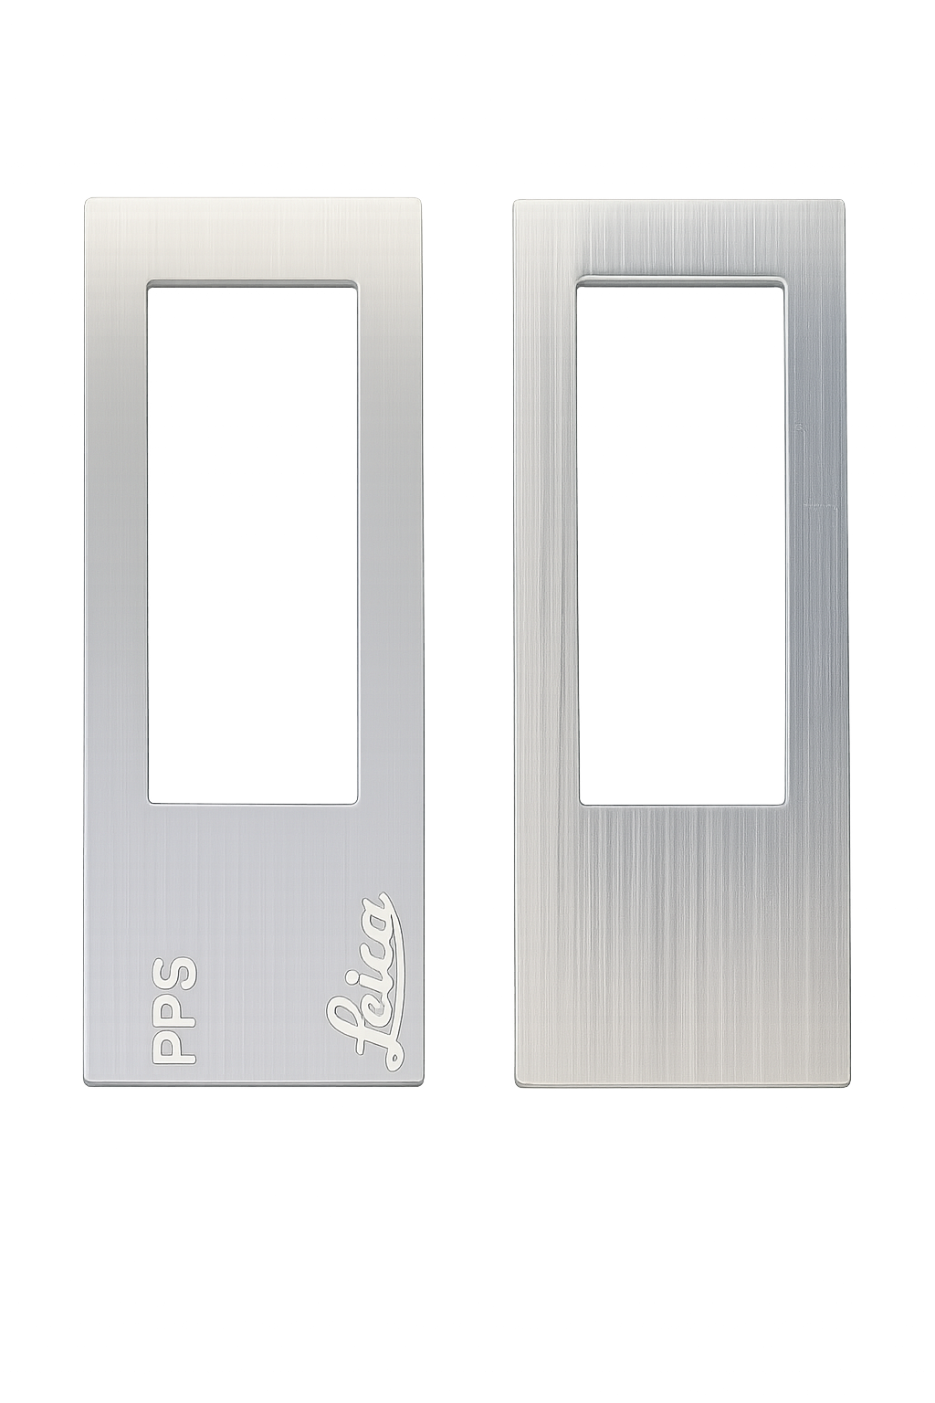 | 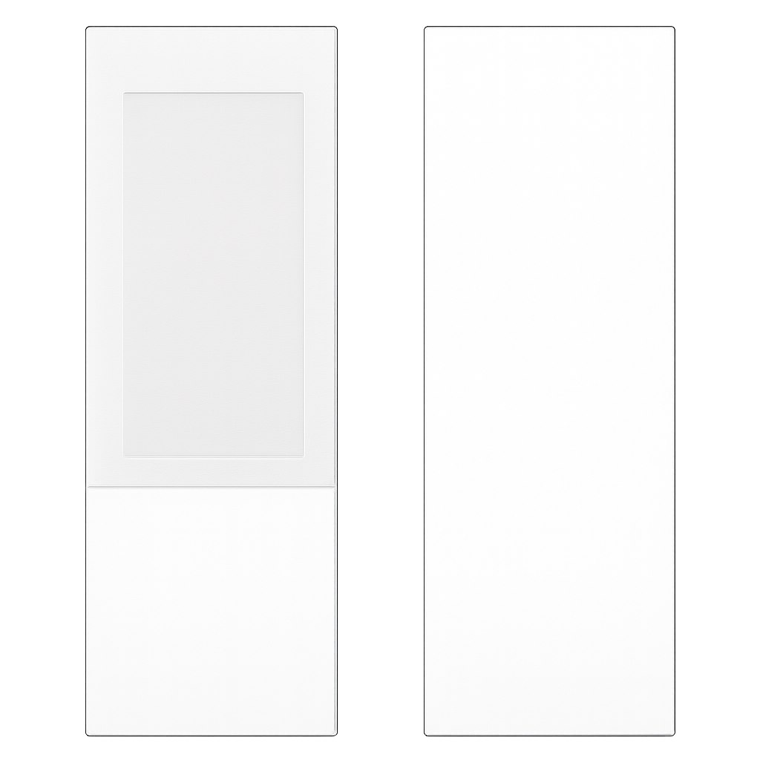  Attach tissue section on indicated sides, metal frame (Left) and glass-backed (Right)

CRITICAL
Always place the tissue section onto the membrane side of the slide, within the membrane area. Sections placed on the frame or glass will not be accessible to the LMD laser.
Metal-frame PPS slides: the membrane is on the inner face of the frame, place the section at the back of the slide so you can mount a coverslip. PEN glass slides: the membrane faces upward when the label is readable normally. Check slide orientation before picking up every section.

- Continue sectioning and mounting as needed. Clean paraffin debris from the blade with ethanol between sections to prevent carry-over.
- Place mounted slides in the 37°C oven overnight to dry and adhere the tissue firmly to the membrane.

TIP
Section 5 to 10 slides per block while the block is cold. The block warms up during cutting and sections become harder to cut cleanly. Return to ice between batches if needed.
Check each mounted section under a light box or dissecting scope before drying — wrinkles and folds cannot be corrected after the slide enters the oven.

3. Staining Reagents
Prepare or check the following reagents before beginning the staining protocol. All should be at room temperature unless otherwise stated.

Reagent / Item | Detail
Xylene | Deparaffinisation (3 × 3 min dips). Handle in fume hood.
100% Ethanol | Rehydration series
80% Ethanol | Rehydration series
50% Ethanol | Rehydration series
Distilled / ultrapure water | Rinse steps and hematoxylin wash
PBS | Final wash before coverslipping
Harris Hematoxylin | Nuclear stain
Acid-Alcohol | 1% HCl in 70% ethanol — differentiator
Scott's Tap Water Substitute (STWS) | Bluing agent (sodium bicarbonate/magnesium sulfate)
Eosin | Cytoplasmic counterstain
Aqua-Poly Mount | Hydrophilic coverslip mountant — store at 4°C

NOTE
Harris Hematoxylin is used in preference to Mayer's Hematoxylin as it produces stronger nuclear staining for 10 μm sections.
Xylene may be substituted with Neo-Clear if available. 99% ethanol is equivalent to 100% for this purpose.

4. Deparaffinisation and H&E Staining
Initial Setup
- Set the oven to 60°C and pre-warm it before starting.
- Place slides in a slide rack. Make sure slides are fully dried from the overnight 37°C step before beginning.

Deparaffinisation and Rehydration
- Place slides in the 60°C oven for 10 minutes to melt residual paraffin and improve xylene penetration.
- Transfer slides through the deparaffinisation and rehydration series. Always dip the slides several times in the next solution before beginning the timed incubation.

Step / Reagent | Duration | Notes
Xylene | 3 min × 3 | Handle in fume hood
100% Ethanol | 2 min × 2
80% Ethanol | 2 min
50% Ethanol | 2 min
Distilled water | 2 min | Slides are now fully rehydrated

Staining Sequence
- Pass slides through the staining sequence below. Always dip slides a few times in each solution before starting the timed incubation to ensure even penetration.

Step / Reagent | Duration | Notes
Hematoxylin | 30 sec | 10 μm sections may need slightly longer than 5 μm — judge by colour
Running tap water (rinse) | 1 min | Leave tap running until water runs clear from slides
Acid-Alcohol (1% HCl / 70% EtOH) | 30 sec | 10 μm sections may need longer than 5 μm — monitor differentiation
Distilled water (rinse) | 2 min
Scott's Tap Water Substitute | 30 sec | Incubate until sections turn blue; may be shorter
Distilled water (rinse) | 1 min
Eosin | 1 min
Distilled water (rinse) | 2 min
50% Ethanol | 1 min | Begin dehydration
80% Ethanol | 1 min
100% Ethanol | 1 min × 2 | Allow slides to briefly air-dry before mounting

CRITICAL
Do not allow slides to dry completely between ethanol and xylene steps during deparaffinisation or dehydration — dried-out tissue causes artefacts.
After the final 100% ethanol step, allow only brief air-drying (30–60 seconds) before mounting. Over-drying causes the membrane to buckle and the mountant to spread unevenly.

5. Coverslip Mounting
- Prepare the coverslip lying flat on a clean tissue. Apply Aqua-Poly Mount (hydrophilic mountant) using a disposable pipette on one side of the coverslip gently by placing a few drops. Gently lower the coverslip at an angle from one side, allowing it to fall slowly onto the mountant without trapping air bubbles.
- Check for bubbles and dry patches. Gently press with a cotton swab at the edges if needed — do not press in the centre.
- After a few seconds, place the covered slide upright and check for bubbles and dry patches. Gently press with a cotton swab at the edges if needed — do not press in the centre.
- Return Aqua-Poly Mount to the 4°C fridge immediately after use.
- Leave slides flat at room temperature for 30 minutes to allow the mountant to set before imaging.

TIP
Aqua-Poly Mount is water-based and compatible with the PEN/PPS membrane. Do not use solvent-based mountants (e.g., DPX) as they can be more difficult to remove before cutting.
Apply mountant only within the membrane area. Mountant on the frame or label area makes the slide harder to handle in the LMD holder.

6. Imaging and Storage
IMPORTANT
Remove the coverslip as soon as possible after imaging. Prolonged mounting medium contact hardens the coverslip in place and makes removal increasingly difficult, which risks tearing the membrane and destroying the tissue section.

- Image slides using the NanoZoomer at appropriate magnification. Ensure the image file is saved and exported before proceeding.
- To remove the coverslip: immerse slides in PBS in a staining jar. Gently agitate by rotation. Slide the coverslip off to the side — do not lift it straight up. Allow no more than 10 minutes total immersion time.
- Dip the slides several times in fresh PBS to remove residual mounting medium.
- Briefly dip in ultrapure / milli-Q water to desalt.
- Allow slides to air-dry for 5–10 minutes at room temperature.
- Store slides at 4°C in a sealed slide box until laser microdissection.

CRITICAL
Do not store slides at -20°C after staining — freeze-thaw cycles cause condensation which disrupts the staining and can detach the section.
Keep slides away from light during storage. Faded H&E staining makes morphological annotation for LMD much harder.

TIP
Image the slides the same day as staining where possible. If same-day imaging is not possible, slides can be stored unsealed at 4°C overnight and imaged the following morning.
Use the NanoZoomer Z-stacking feature for 10 μm sections if morphological detail in depth is needed for annotation.

Questions & Contact
For advice on sectioning, staining optimisation,
H.Caldwell@ed.ac.uk

to arrange laser microdissection, contact:
air-support@igc.ed.ac.uk

mass-spec@igc.ed.ac.uk for any mass spec questions
institute-genetics-cancer.ed.ac.uk/mass-spectrometry

